Excel Assignment-2

1. The dollar sign**locks the column or row proceeding it**.  If you want to lock the column, add the dollar sign before it e.g. to lock the column in the reference B2, adding the dollar sign before the column letter makes it $B2. Same goes for the row; B2 with a locked row will be B$2.

3. When evaluating a formula, Excel follows a standard math protocol called "order of operations". In general, Excel's order of operation follows the acronym PEMDAS (Parentheses, Exponents, Multiplication, Division, Addition, Subtraction) but with some customization to handle the formula syntax in a spreadsheet.

First, any expressions in parentheses are evaluated. Parentheses essentially override the normal order of operations to ensure certain operations are performed first.

Next, Excel will resolve references. This involves replacing cell references like A1 with the value from the cell, as well as evaluating range references like A1:A5, which become [arrays](https://exceljet.net/glossary/array) of values. Other range operations like union (comma) and intersection (space) also happen at this time.

Next, Excel will perform exponentiation, negation, and percent conversions (in that order), followed by multiplication and division, addition and subtraction, and [concatenation](https://exceljet.net/glossary/concatenation). Finally, Excel will evaluate [logical operators](https://exceljet.net/glossary/logical-operators), if present.

4.Top 5 functions of excel are:

* If function-allows you to compare two values and receive an output based on the answer.

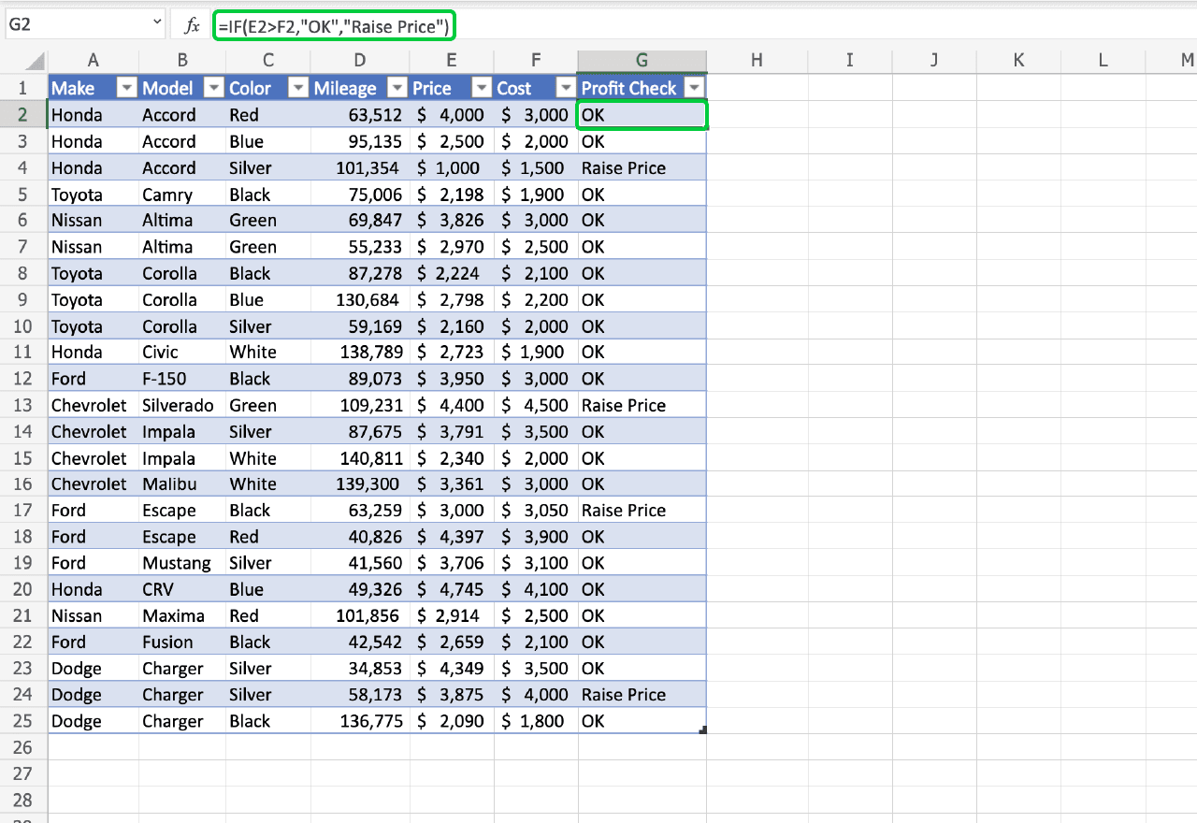

* Sum function-It sums the items in a specified range. 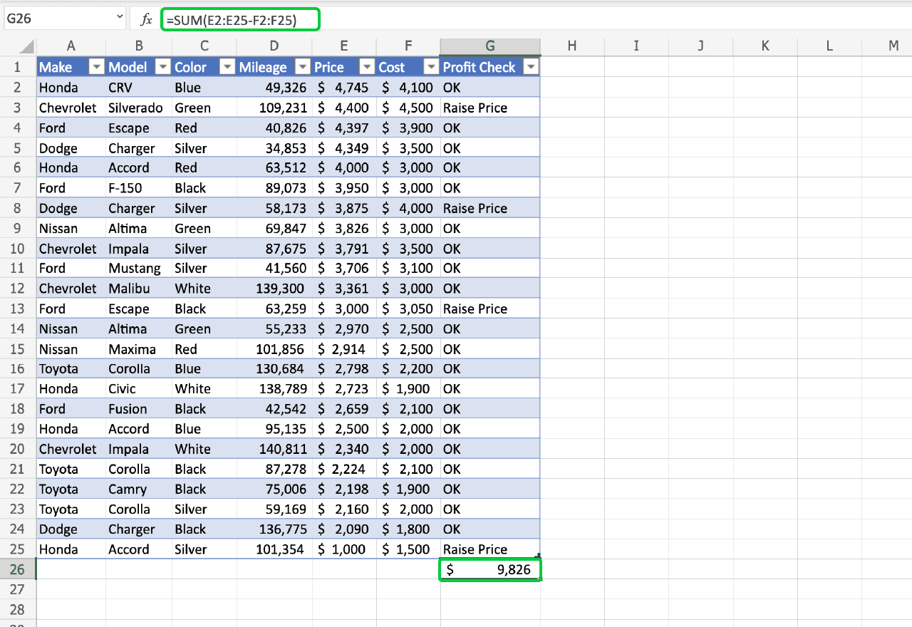
* Subtotal- Depending on the modifier you include, SUBTOTAL can display the average, count, or rage of your data set, among other things. 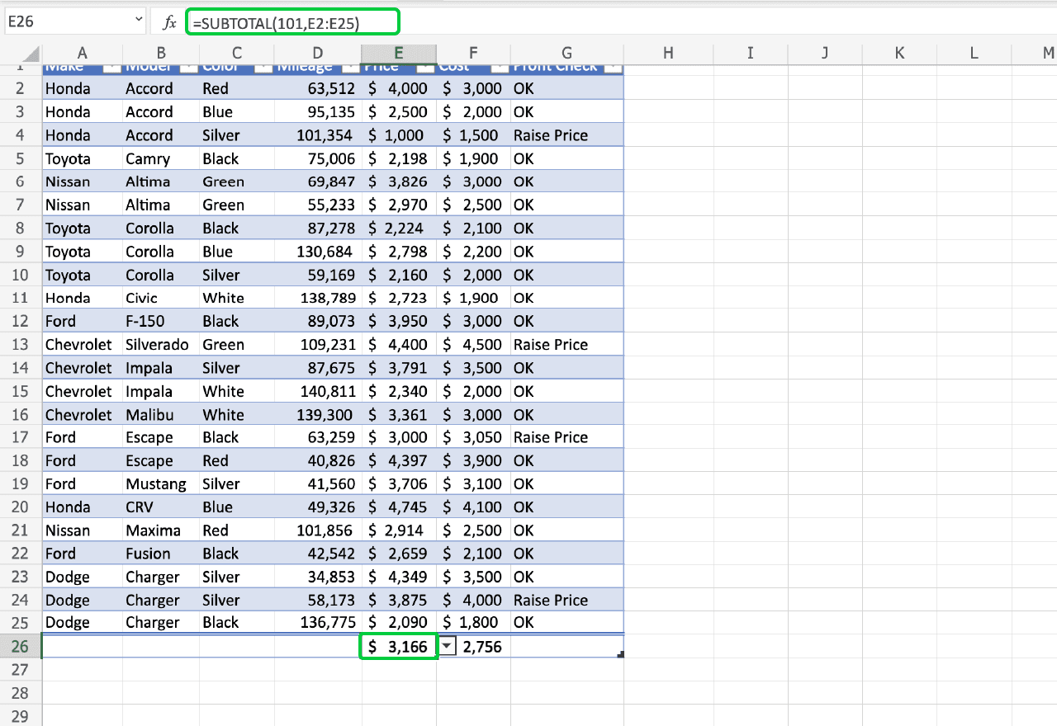
* Concat-The [CONCAT function](https://support.microsoft.com/en-us/office/concatenate-function-8f8ae884-2ca8-4f7a-b093-75d702bea31d) joins, or concatenates, the inputs. It’s that simple. 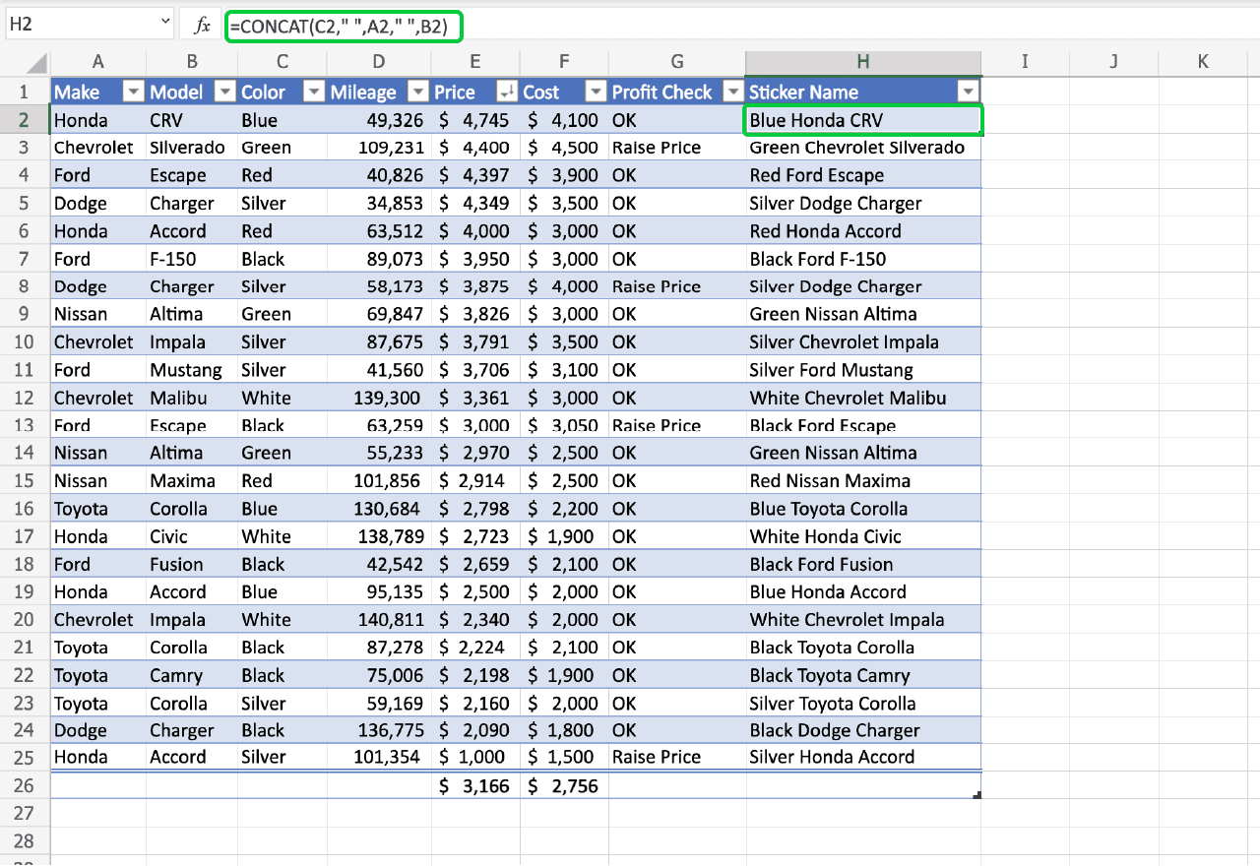
* CountIf-[COUNTIF](https://support.microsoft.com/en-us/office/countif-function-e0de10c6-f885-4e71-abb4-1f464816df34) is a conditional counter, which means it only counts cells that fulfill an argument you give it. 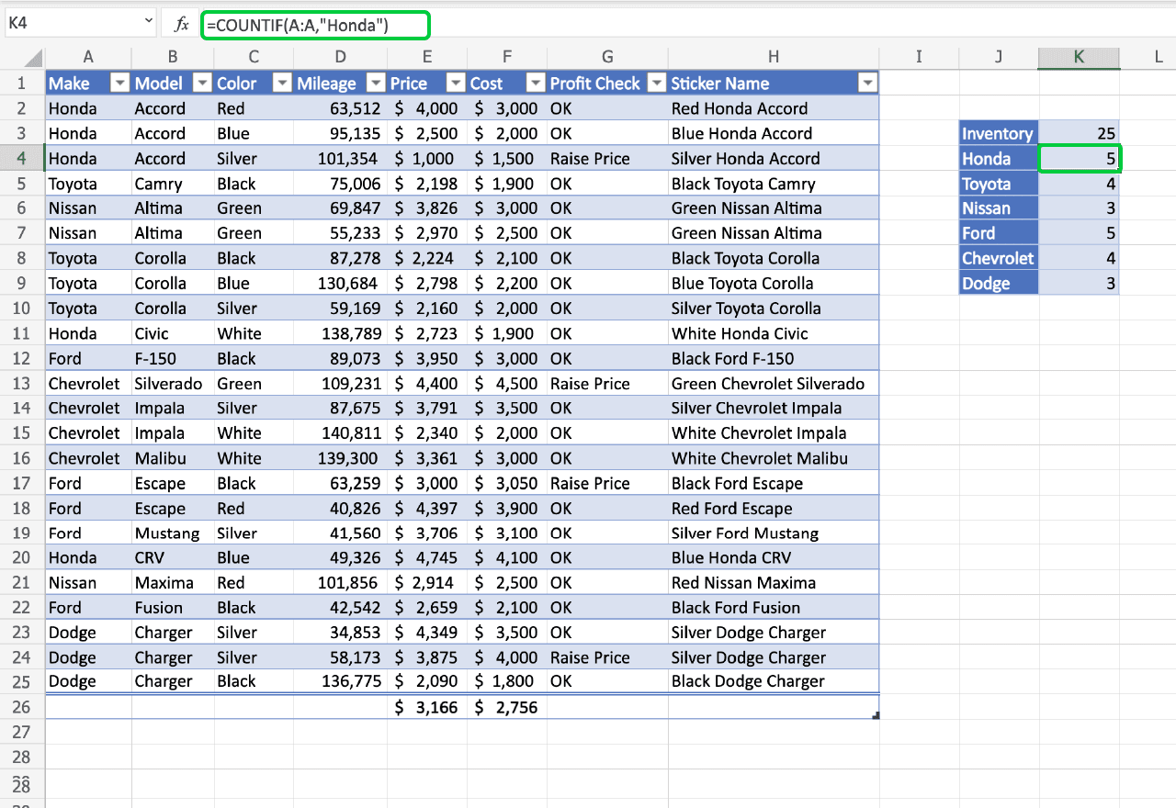

5. Sometimes, we need data based on different categories. SUBTOTALS help us to get the totals of several columns of data broken down into various categories.

For example, let’s consider garment products of different sizes manufactured. The SUBTOTAL function will help you to get a count of different sizes in your warehouse.

### 6. VLOOKUP Formula

=VLOOKUP(lookup_value, table_array, col_index_num, [range_lookup])

To translate this to simple English, the formula is saying, “Look for this piece of information, in the following area, and give me some corresponding data from another column”.

The VLOOKUP function uses the following arguments:

1. Lookup_value (required argument) – Lookup_value specifies the value that we want to look up in the first column of a table.
2. Table_array (required argument) – The table array is the data array that is to be searched. The VLOOKUP function searches in the left-most column of this array.
3. Col_index_num (required argument) – This is an integer, specifying the column number of the supplied table_array, that you want to return a value from.
4. Range_lookup (optional argument) – This defines what this function should return in the event that it does not find an exact match to the lookup_value. The argument can be set to TRUE or FALSE, which means:
   * TRUE – Approximate match, that is, if an exact match is not found, use the closest match below the lookup_value.
   * FALSE – Exact match, that is, if an exact match not found, then it will return an error.